MAMOOK IPSOOT: grunt gallery is looking for Native youth artists!
Project Summary:
Netherlands artist, Desiree Palmen, will be travelling to Vancouver in July to work with urban native youth to explore their experiences and feelings in relation to Vancouver’s landscape. The project will be titled, MAMOOK IPSOOT (Chinook translation: To Hide/Make Hidden). The artist will spend 3 weeks working with youth to paint them into a chosen place in Vancouver. These on-site painting projects will be photo-documented and these images will be publicly displayed in various locations within Vancouver by the fall. This is an amazing opportunity to work with an international artist and to have artwork exposed to various artists in public places across the city.
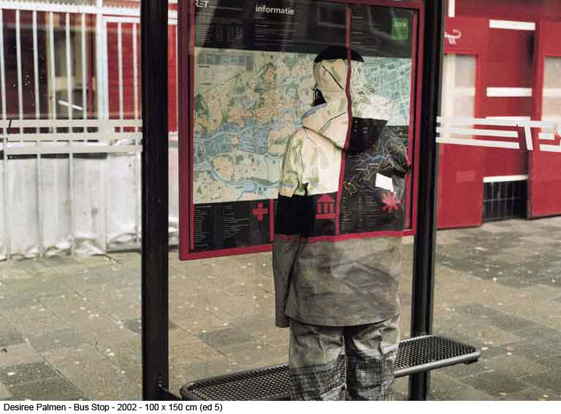
Youth Requirements:
- Participating youth must be between the ages of 11-15.
- Identify as First Nations, Metis or Inuit.
- Reside in the Vancouver area.
- Bring loose fitting white cotton trousers, long sleeved shirts and headgear to be painted upon. Please note that these articles of clothing must be white so that painted colors show up vibrant and clear.

Workshop Dates:
July 9, 11, 16, 18, 23, 25.
Each workshop session will take place in the afternoon and will be roughly 3-4 hrs in length. Because of the nature of the project, there is a need for all of the participating youth to make a time commitment from the beginning to the end of the project.

Project Details:
Palmen has a history of working with youth who reside in areas where their connection to the land is extremely important to them culturally and historically. Check out the youth project, Hide & Seek, from Istanbul here: http://www.desireepalmen.nl/hideandseek.php
Part of the project will occur indoors, in the amenities room located next to grunt gallery's facility. The other part will occur outdoors at a location chosen by the participating youth. The youth will wear clothing that will be painted on to help camouflage them into the area they have chosen. The artist has requested that youth have a pair of white cotton trousers and a white cotton long-sleeved shirt and some type of headgear that can be used to paint on. The clothing should be loose fitting so that the youth can pull it over the regular clothing they are wearing.
grunt is looking for 8 Native youth artists who are between the ages of 11-15 who reside in Vancouver. grunt wants to ensure that the participating youth have an interest in the arts as this is an incredible opportunity to work with an international artist. Participating youth will be paid an artists' honorarium for their work and commitment to the project. The camouflaged painting scenes will be photographed and video documented (there will be a 10-minute video created on the project that will be shown during its launch date in the Fall - Sept/Oct). The photographs of this project will be shown in bus shelter ad spots and various other locations throughout Vancouver.
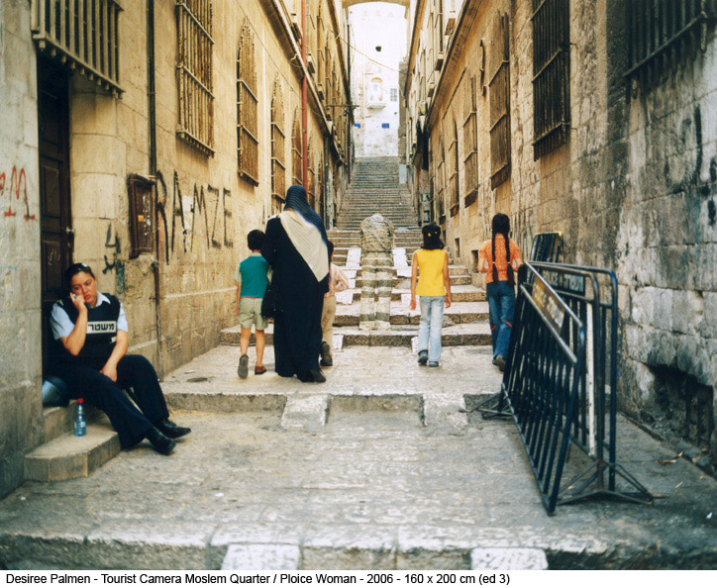
If you'd like to take part in this project, please email Karlene at karlene@grunt.ca

http://grunt.ca/mamook-ipsoot-looking-for-native-youth-artists/

